AGM
Thanks to everyone who attended the AGM last November. It was a very constructive meeting which covered a range of topics. Apart from the outcomes of the motions which have already been covered, other issues discussed included raising our media profile, sponsorship and fundraising, observers and crews for the longer swims and reviving the 3 Bays swim.
It has been suggested that we hold the AGM on an evening in November instead of the morning after the dinner. What do you think? Let us know whether this would suit you better.

New Year’s Day Swim
With the windy weather threatening to cancel the swim, we got a lucky break in the clouds and the sun came out long enough for us to get in for a swim. Well done to everyone who took part. Thanks to St. Catherine’s sailing club for the use of their club house for soup and nibbles afterwards. Thanks to Marilyn, Dee and Jenny for providing the soups. A great start to the New Year. About £80 was collected in donations for Macmillan Jersey.
RJ & J2F swims
We are compiling a list of possible observers for these swims. If anyone who has not done it before is interested in becoming an observer, please contact Martin Powell or Adrian Follain for more information.
The CSPF have recently changed their medical forms for 2018.
“In recent years we had an increasing number of complaints from GPs either questioning or unwilling to sign on a very explicit and definite "X is fit/unfit to swim the Channel": newer generations of GPs are more legally aware and as we all know no one can say for definite what it means to be "fit to swim the Channel". “
In response, we went through a legal exercise where we commissioned a QC to review this form and suggest an alternative. We ended up with a much weaker, double-negative statement:
"I have carried out an examination of the swimmer named below that I consider to be reasonably necessary and in my opinion the swimmer suffers from no health condition which means that the swimmer should not attempt to swim across the English Channel either solo or as part of a relay team"

We have decided to adopt these changes and so are in the process of amending our medical form. At the same time we will review our swim qualifier form.
CONGRATULATIONS TO….
*** Results ***
Congratulations to the following people for the ASA masters national T30 competition
Female 18-24 JLDSC Chantelle Le Guilcher 4th
Female 25-29 JLDSC Alice Harvey 9th
Male 25-29 JLDSC Robin Johnson 5th
Male 35 - 39 JLDSC Andy Truscott 3rd
Male 35 - 39 JLDSC Vaughan Robinson 7th
Team event 110 - 119 age JLDSC (Chantelle, Alice, Robin and Vaughan) silver -2nd

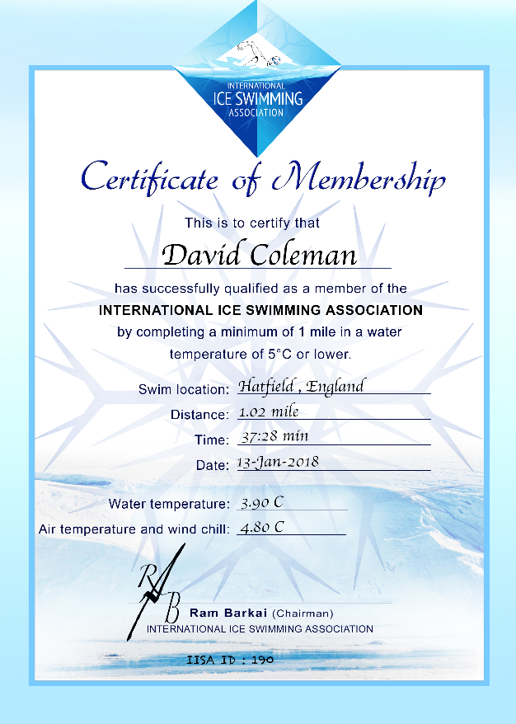
Congratulations to life member David Coleman from the UK who recently completed his second ice mile swim.

This weekend three more JLDSC life members, Wendy Trehiou, Graeme Lowe and Adrian Sarchet (from Guernsey) aimed to join the exclusive ice mile club.
On a really rotten day, wet, windy with a strong head wind on the lake and a water temp of 4.4 and air temp of 3 with a severe wind chill both Adrian and Graeme completed the ice mile, however, Wendy asked to get out just short of 100m from the finish.
An amazing achievement by all of you. Well done!

Wendy is raising money for Macmillan please see the link below for her sponsorship page!
https://www.macmillanjersey.com/…/sponsor-a-fundrai…/4111-2/

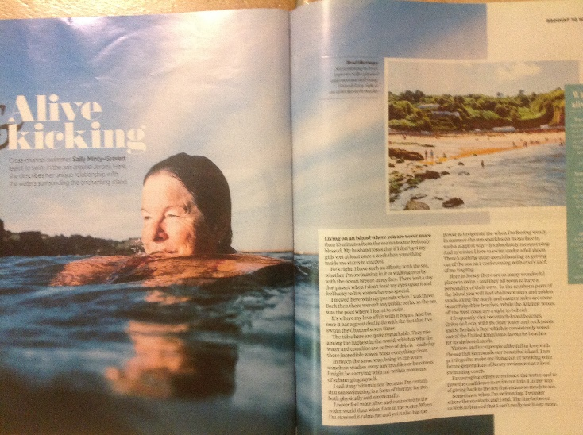

More positive coverage of the benefits of open water swimming. This article appeared in the Daily Telegraph Magazine in January.

COMMITTEE BUSINESS
As part of our aim to raise the club’s profile in the community and grow our number of helpers, we have now registered with Volunteer.je looking for kayakers that might be willing to help out during some of our swims.

Sea Swimmer 2
The club boat will be out of the water next week for her annual service and spruce up. If you can spare an hour or two over the weekend 10th & 11th February to help clean and antifoul the boat, please let us know. Cake will be involved!
We shall also be having an AIS transceiver fitted. This is an automatic tracking system enabling other ships and maritime authorities to track and monitor ship movements. It will replace the SPOT trackers we have used in the past to follow swims.

Your committee have also attended the recent Jersey Sport networking event and the travel grants workshop.

English Channel swim slot
The club has an English Channel slot booked on the tide 8-14 August 2019. For more information and how to apply either for yourself or a relay you’d like to organise, please contact Jenny.

Thanks to Chantelle Rose for organising our inclusion in the Waitrose green token scheme for January. It certainly looked like we had lots of support and we await the final amount raised.

To kick start our fundraising this year, Marilyn has filled a large jar full of yummy lollipops.
Just guess the correct number (or nearest) to win!
50p a guess. Marilyn will bring it along to the pool on Tuesdays.

We will also be starting a football card. £1 a go.

UPCOMING EVENTS

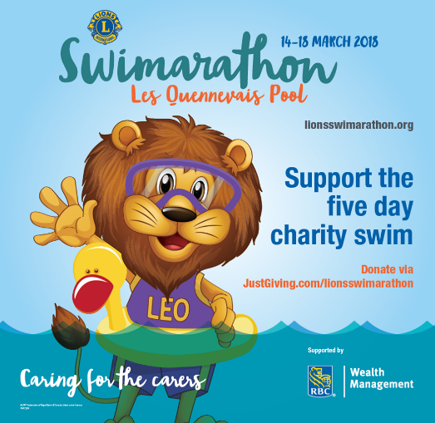

Swimarathon
This year we are swimming on Saturday 17th March at 4pm and have all 8 lanes again. Please contact Chantelle Le Guilcher if you want to join us.

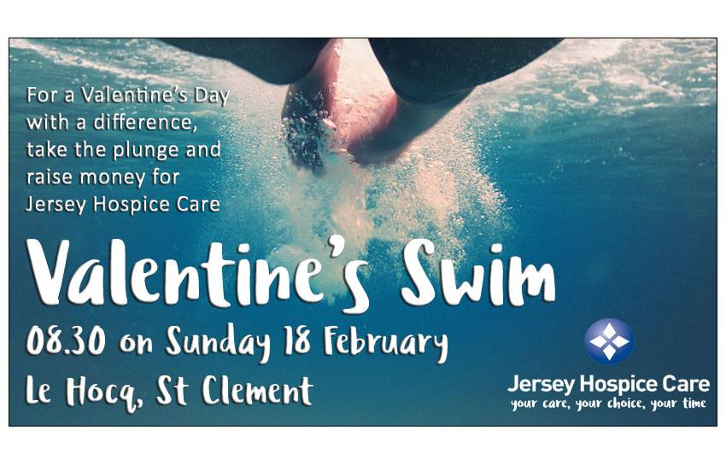
Valentine Day’s Swim
Sunday 18th February. 8.30am Le Hocq. Come and support Jersey Hospice.

Postal Swim
The junior swim is on 6th February and the seniors is on 20th February.
The postal swim is free for all to do and paid by the club for you. It would be nice to get a good number of entries this year. All you have to do is swim for an hour.
Would be handy if each swimmer could supply a lap counter but if your unable to then don’t worry. Let me know and we will try our hardest to supply you one. If you could email me at andytruscott2404@icloud.com and let me know if a) you are swimming and b) if you need a lap counter.
If you are a fellow swimmer or parent and don’t want to swim but happy to give us an hour of your time to help count then I would appreciate that and would equally love to hear from you.

